**OUTREACH SCHOOLS EXAMINATION BOARD**

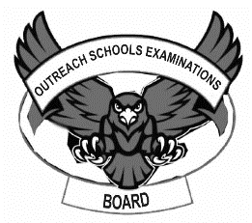 **END OF TERM II EXAMINATION 2024**

**MIDDLE CLASS: (4 – 5 YEARS)**

**LEARNING AREA 5: LANGUAGE DEVELOPMENT II**

**My name is: ………………………………..………………………….**

**My School is: ……………………………..……….…………………..**

**I am in: ………………………………..…………………………………………..**

1. **Match syllable to word.**

ba sun

ma box

su jug

ju bag

bo man

1. 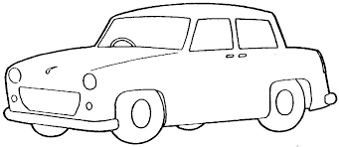**Name the pictures of sound c.**

**__________________**

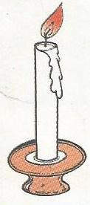

**___________________**



**___________________**



**____________________**

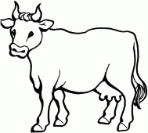

**____________________**

**(candle, cow, cup, car, cat)**

1. **Fill in the sound ‘u’.**

g ___n c ____p m ____g

h ____t s ____n r ____n

1. **Ring the same sounds.**

s 5 s

b b 6

9 p p

e g e

a a d

1. **Copy and write.**

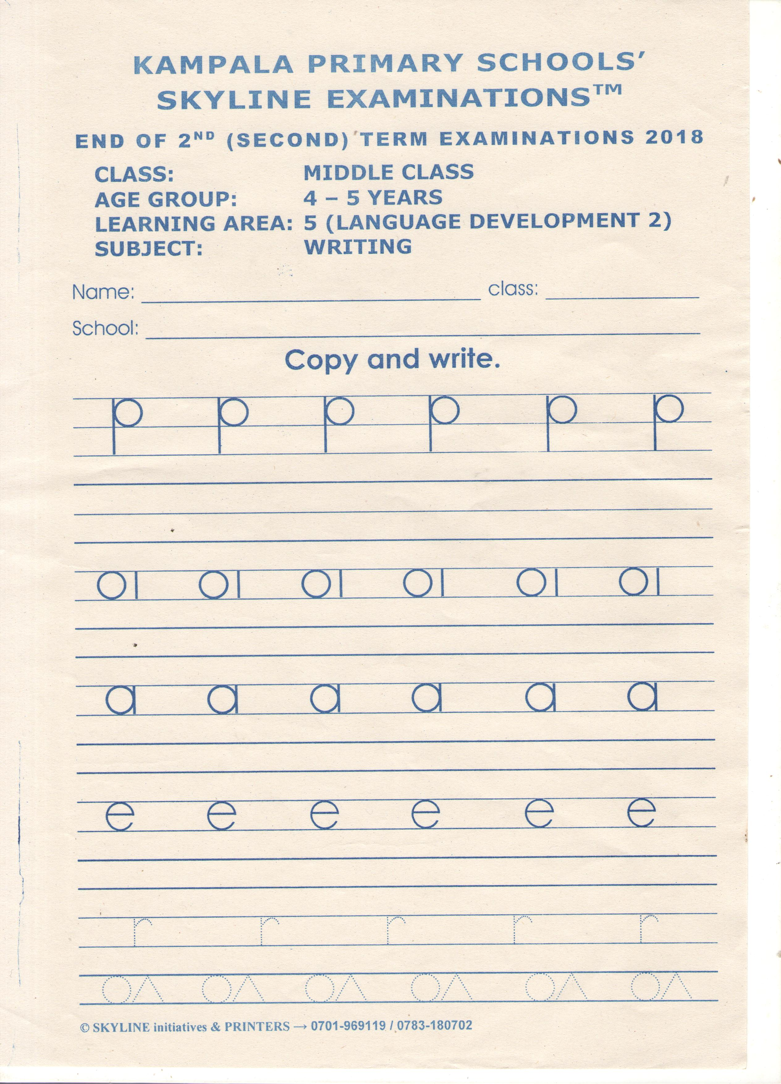

**END**